Serial No:
2nd Midterm Exam
Total Time:1 Hour
Total Marks: 50
________________
Signature of Invigilator

EE-227 Digital
Logic Design
Monday 27th March, 2017
Course Instructor
Dr Mehwish Hasan, Ms Mehreen Alam & Mr. Jawad Hassan

_____________________________________________ _____________________
Roll No Section Signature

DO NOT OPEN THE QUESTION BOOK OR START UNTIL INSTRUCTED.
Instructions:
- Attempt on question paper. Attempt all of them. Read the question carefully, understand the question, and then attempt it.
- No additional sheet will be provided for rough work. Use and mark the back of the last page for rough work.
- If you need more space write on the back side of the paper and clearly mark question and part number etc.
- After asked to commence the exam, please verify that you have Nine (9) different printed pages including this Title page and a rough work page at the end. There are total of five 5 questions.
- Use permanent ink pens only. Any part done using soft pencil will not be marked and cannot be claimed for rechecking.
- For each question show your complete method in solution.

 | Q-1 | Q-2 | Q-3 | Q-4 | Q-5 | Total
Total  Marks | 5 | 10 | 10 | 18 | 7 | 50
Marks Obtained

Vetted By: ____________________________Vetter Signature: _____________________

Q1. [ 5 pts] Design a half-adder (inputs: A, B, outputs: S and C_{out}) using only 2-input NOR gates. For full credit, you must use minimum number of gates as possible.

Q2. [ 10 pts] What function is implemented by the following 2 x 1 MUX implementation? Do show intermediary output functions for full credit.
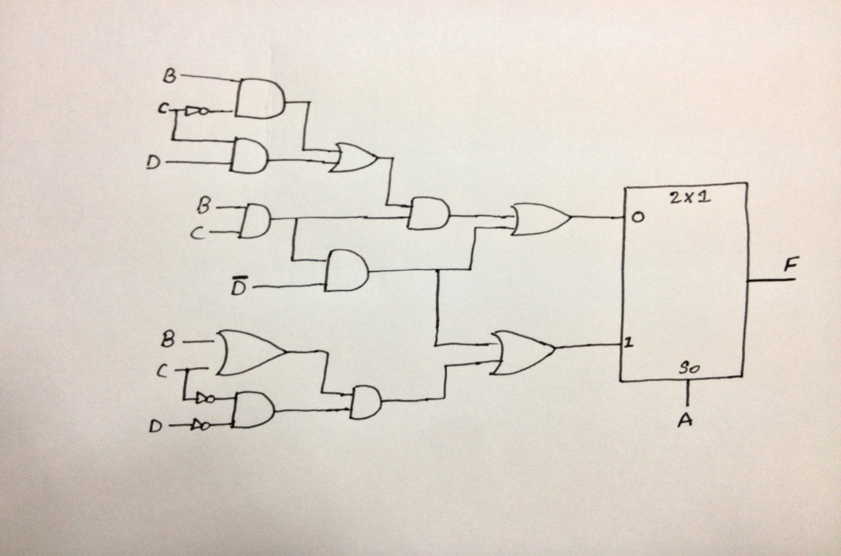

Q3. [ 2+4+4+2 = 10 pts] Consider a 4-bit priority encoder with the priority sequence D₁ > D₀ > D₃ > D_{2.}
a. Write the priority table.

b. Write the complete 4-bit table.

c. Write minimized equations.

d. Draw the resultant circuit diagram. Do not show the internal encoder implementation.

Question No.4 [2 + 4 + 6 + 6 = 18]
Q4. [ 2+4+6+6 = 18] Design a combinational circuit for data integrity (data correctness using parity bit) checker that has four inputs A₃, A₂, A₁, and A₀ and one output F_{i}. The output will used to implement odd parity i.e., the output F_{i} = 1 when input has even number of 1's and 0 otherwise.

a. Construct truth table for F_{i}

b. Minimize the function and draw the circuit

c. Implement the function F_{i} using 3 x 8 decoders with enable lines.

d. Implement the function F_{i} using 2 x 4 decoders with enable lines.

Q5. [ 3+4 = 7 pts] Draw SR latch with NAND gate and give its function table.

ROUGH WORK SHEET

